# 

**Bangladesh Computer Council , ICT Division**



## Course Title:Smart Office Management

## Assignment On

**E Book Project By Ms Word**



**Trainer: Santosh Kumar Sushil Sir Mobile:01814328156**

[**Email:**](mailto:abedins777@gmail.com)**santosh.kumar@diit.info**

**Student:Hore Jannath Mobila:01854495309**

[**Email:horejannath@gmail.com**](mailto:horejannath@gmail.com)



# My College:Government Hazi Mohammad Mohsin College

Government Hazi Mohammad Mohsin College is one of the renowned colleges of Bangladesh located in Chittagong.Named after Mohammad Mohsin,a 19th- century philanthropist-,it is one of the oldest educational institutions in the country.

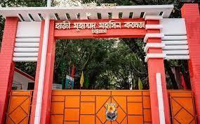

Adress:College road Chawkbazar Chittagong,Bangladesh

College Code:4305 EIIN:104527 Phone:02333364690

Website:https://mohsincollege.edu.bd/



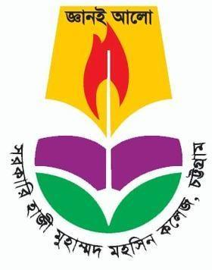

| Motto | Knowledge for enlightenment |
| --- | --- |
| Established | 1874 |
| Founder | Mir Abdur Rashid |
| Principal | Professor Mohammed Quamrul Islam |
| Students | 20,000 |
| Campus | Urban,31 acres |
| Language | Bengali and English |
| Type | Public |

**E BOOK Proiect by MS Word**

**History:**Chittagong Madrasa was established in 1874 using a waqf donated by Mohammad Mohsin.In 1918,plans to improve education at the intstitution were developed and by 1927 it had gradually evolved into Islamic Intermediate College came into existence when the two institutions merged.In 1996,the attached high school was relocated as Mohsin School.

**Campus:**The college has eight buildings which cover almost 31 acres of land.

**Hostel:**Two hostels situated to the west of the administrative Buliding offer housing for one hundred students.Another hostel and the deans residence are situated south of the Commerce Department Building.

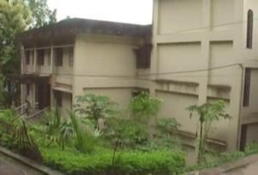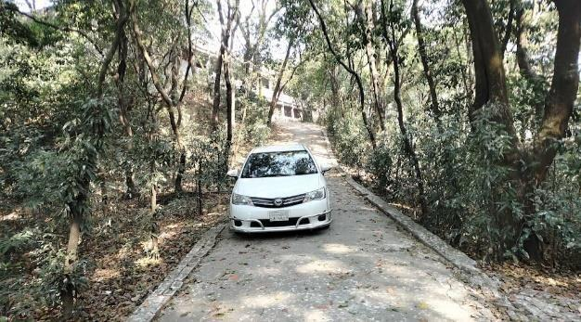

**Portuguese Building:**One of the buildings is a almost a century oil.It is called Darul Adalat and it was the first court of Chittagong under British colonial rule;the site may also have been fortified by Portuguese pirates in the 16th century.

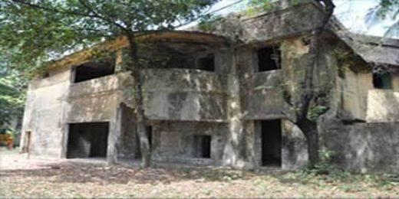

**Mosque:**On top of a hill stands the college mosque.

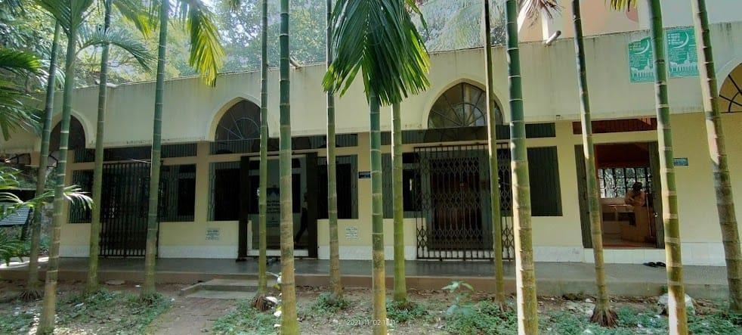

**Academic Building:**

1. Science Building
2. Administration Building
3. Arts Building
4. Business Administrative Building
5. New Academic Building

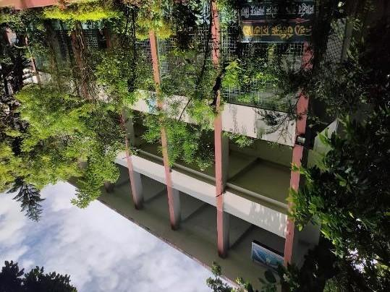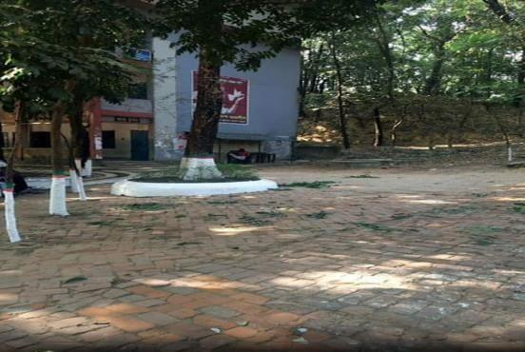

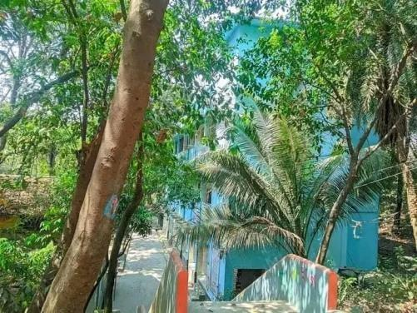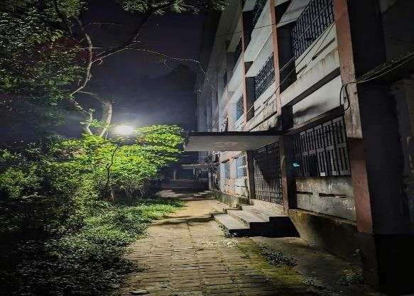













**3 years HSC Result**

1800

1600

1619 1615

1698

1400

1334

1285

1200

1000

868

800

600

400

200

99.77%

|  | 2023 | 2022 |  | 2021 |
| --- | --- | --- | --- | --- |
| Passed | 1619 | 1615 |  | 1698 |
| GPA 5 | 868 | 1334 |  | 1285 |
| Passing Rate | 99.77% | 99.04% |  | 99.07% |
|  |  |  |  |  |
|  |  |  | Axis Title |  |

0

99.04%

99.07%



Passed GPA 5 Passing Rate



## Teacher 1Informations:

| **SL No** | **Name** | **Designation** |
| --- | --- | --- |
| **1** | Professor MD Quamrul Islam | Principal |
| **2** | Professor Banuara Begum | Vice Principal |
| **3** | Dr. A.K.M. Ileas | Teacher |
| **4** | Rajot Shuvra Chakraborty | Assistant Professor |
| **5** | Bilas Krishna Chakraborty | Assistant Professor |
| **6** | Dip Shikha Dhar | Assistant Professor |
| **7** | Joly Paul | Assistant Professor |
| **8** | Amir Kanti Dey | Assistant Professor |
| **9** | Golam Murtoza | Assistant Professor |
| **10** | Aniruddha Sengupta | Assistant Professor |
| **11** | Angshuman Chakraborty | Assistant Professor |
| **12** | Prodip Kumar Biswas | Assistant Professor |
| **13** | Shyamoli Rani Paul | Assistant Professor |
| **14** | Nurunahar Mursheda | Lecturer |
| **15** | Choitanya Prasad Roy | Lecturer |
| **16** | MD. Abdul Hamid | Lecturer |
| **17** | Salam Khanom | Lecturer |
| **18** | MD. Aminur Rahaman | Lecturer |
| **19** | Monalisa Choudhury | Lecturer |
| **20** | MD. Salaiman Ali | Lecturer |
| **21** | Mrityunjoy Paul | Lecturer |

**E BOOK Proiect by MS Word**

## Student Dormitories:

There are two male and one female student dormitories

## College Ground:

The college has a large ground .And this ground students from the college and from other colleges play Cricket,Football.

## Co-curricular activities:

BNCC,the college has th HQ of karnaphuly battalion-2 of Bangladesh National Cadet Corp.Two Sections are Army Wing and Naval Wing.